Trainees in Difficulty – teaching reflective practice

How to Teach Reflective Practice and using Kolb and Schon

- Role model explicitly what you are doing and thinking when being observed. For example in a joint surgery identify what you are thinking at different moments in time. As one student said it is better for you to reflect out loud than for me to try to guess the thought bubbles coming out of your head. My experience is that patients also like this and join in if asked with their perspectives.

- For a trainee who frequently just thinks about a patient’s disease take them on the patient’s journey. Explore with them the patient’s illness and the journey that individual takes from thinking about coming to see a doctor, what story they are planning in the waiting room, the consultation itself and what they will say to family, friends or work colleagues afterwards

- Try some reflective writing and move from a descriptive narrative to one with some reflection and then to include feelings in the reflection. Ask a trainee to write a factual story describing a patient’s consultation. Then ask them to write down reflections about that individual patient. Then ask them to consider what feelings this might evoke in the patient and how they themselves felt during difficult parts of a consultation. What was it that made them feel better? For example was it something the patient said or a good question giving better insight or perhaps just safety netting? (Remind them of Helman’s folk model of the consultation.)

- During case discussions share the benefits of time spent reflecting about what went on.

- Help the learner understand that when we are sharing reflections they are the start of positive change and that this is not a summative assessment

- Discuss the 5 levels of reflection.
- A description of what has happened, the learning event or the basic evidence data
- A description of what the learner’s response is to level 1
  - What do they think of it?
  - What sense do they make of it?
  - What does it all mean to them?
  - How did it make them feel?
- A description of the learner’s awareness of the consequences or implications of level 1 on their practice of medicine, or their GP practice or their current situation.
- A description of other information that relates to this such as
- Research articles
- Guidelines
- Editorials or reviews
- Conversations with experts
- A description of the changes that have actually occurred as a result of the above

- Fully understand Kolb’s experiential learning cycle and simplify it so that it is easy for you and the trainee to understand and use

KOLB’S LEARNING CYCLE
Kolb's learning theory sets out four distinct learning styles (or preferences), which are based on a four-stage learning cycle. (Which might also be interpreted as a 'training cycle'). In this respect Kolb's model is particularly elegant, since it offers both a way to understand individual people's different learning styles, and also an explanation of a cycle of experiential learning that applies to us all.

Kolb includes this 'cycle of learning' as a central principle for his experiential learning theory, typically expressed as four-stage cycle of learning, in which 'immediate or concrete experiences' provide a basis for 'observations and reflections'. These 'observations and reflections' are assimilated and distilled into 'abstract concepts' producing new actions which can be 'actively tested' in turn creating new experiences.

Kolb says that ideally this process represents a learning cycle or spiral where the learner 'touches all the bases', ie., a cycle of experiencing, reflecting, thinking, and acting. Kolb's model therefore works on two levels - a four-stage cycle:
- Concrete Experience - (CE)
- Reflective Observation - (RO)
- Abstract Conceptualization - (AC)
- Active Experimentation - (AE)

and a four-type definition of learning styles, (each representing the combination of two preferred styles, rather like a two-by-two matrix of the four-stage cycle styles, as illustrated below), for which Kolb used the terms:
- Diverging (CE/RO)
- Assimilating (AC/RO)
- Converging (AC/AE)
- Accommodating (CE/AE)

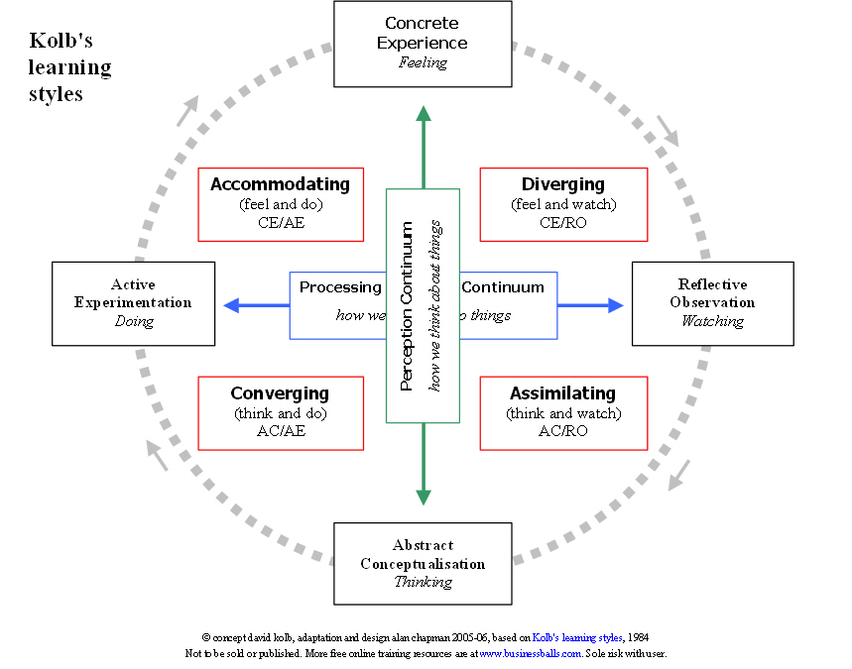

Note the match to Honey and Mumford
- 'Having an Experience' (stage 1), and Activists (style 1): 'here and now', gregarious, seek challenge and immediate experience, open-minded, bored with implementation.
- 'Reviewing the Experience' (stage 2) and Reflectors (style 2): 'stand back', gather data, ponder and analyse, delay reaching conclusions, listen before speaking, thoughtful.
- 'Concluding from the Experience' (stage 3) and Theorists (style 3): think things through in logical steps, assimilate disparate facts into coherent theories, rationally objective, reject subjectivity and flippancy.
- 'Planning the next steps' (stage 4) and Pragmatists (style 4): seek and try out new ideas, practical, down-to-earth, enjoy problem solving and decision-making quickly, bored with long discussions.

There is arguably a strong similarity between the Honey and Mumford styles/stages and the corresponding Kolb learning styles:
- Activist = Accommodating
- Reflector = Diverging
- Theorist = Assimilating
- Pragmatist = Converging

Consider how deep learning begats reflection and a facility for life long learning.
- Do your own and encourage trainees to use PUNS and DENS (17) and at times both use Discomfort Logs. (18) Explore and share reflections on these
- Consider what Reflection means to you and the trainee and consider the different types suggested by Schon.

SCHON'S THEORY OF REFLECTION
Donald Schon (1987) describes professional everyday practice as complex and not easily understood through technical rational models. He refers to this everyday practice as 'the swampy lowlands' of practice, i.e. everyday practice is messy, unpredictable, complex, challenging and stressful. Consequently, the professional practitioner needs to develop ways of understanding the everyday world of practice in order to learn from practice. There are three fundamental constructs in Schon's theory: knowing-in-action reflection-in-action reflection-on-action.

Knowing-in-action
Is the unconscious competence, intuitive knowing about or knowing how to do things. 'When we have learned how to do something, we can execute smooth sequences of activity, pattern recognition and decision making, without having to "think about it". Our spontaneous knowing-in-action usually gets us through the day. However, sometimes a familiar routine may produce something unexpected, that may just not feel right or where it is not possible to solve a problem using the usual strategies. Sometimes even if the problem has been solved, there is something odd about the result. In such situations, practitioners can either ignore the incident - or choose to reflect upon it. Repetitive practice may lead to problems such as no longer questioning the assumptions that underpin practice. Knowing-in-action alone may lead to missed opportunities to think about what they are doing and simply failing to see problems.

Reflection-in-action
Occurs at a time when you can still make a difference to the particular practice situation, i.e. it's 'on-the-spot' reflection. You may be surprised by an event in practice - an unexpected outcome, either pleasant or unpleasant - and find that your practice is interrupted by an immediate reflective response, that is, you are thinking about what you are doing as you do it. Reflection-in-action has a critical function, questioning the assumptions that underpin our knowing-in-action. It gives rise to on-the-spot experimentation because of our awareness and observation of new phenomena or things that occur in our practice.

Reflection-on-action
Is something that you do after the event. You think back about what you have done in order to discover how your knowledge used in practice (knowing-in-action) and your reflection in-action contributed to the outcome of your practice. Reflection-on-action has been widely applied in nursing practice and nursing curricula through a variety of approaches, such as 'reflective writing' (Holly, 1989), group reflection with nursing students (6etliffe, 1996), using art (Cruickshank, 1996) and critical incident analysis (Minghella and Benson, 1995). Your learning diary is, at least in part, a reflective diary too. As you have been making notes in your diary you have been reflecting-on-action. You may have been reflecting on something odd or puzzling, or you may hove chosen to reflect on everyday events that are not odd, or events that are significant at the time
- Use awareness raising questions to trigger reflection and create the right culture for exploring them safely.
- If a learner has difficulty reflecting you can again use logical levels
  - Environment – so for example it is too noisy or uncomfortable
  - Behaviour – this might be because reflective behaviour is a completely foreign concept and thinking remains rigid and structured
  - Capability – the trainee accepts that reflection is a good concept but have no idea how to do it properly
  - Beliefs – the trainee can reflect but believes it is a waste of time or that it is better not to reflect so that their internal feelings are not challenged
  - Identity – the trainee values their role as a diagnostician and has a conviction that doctors know all they need to know when they qualify.

And there is that highest Spiritual level starting to think beyond IQ and EQ and the balance of these of Spiritual intelligence will create deep level and probably life changing understanding of the core meaning of what we do.

The GROW model might help explore this and if you are helping a learner consider what awareness raising questions encourage reflection.

- Establish the Goal
Define and agree the goal or outcome to be achieved. Ask them to reflect using questions like: "How will you know that you have achieved that goal?" "How will you know you are successful and the problem is solved?"

- Examine Current Reality
Ask for reflection on things like "What is happening now?" "What, who, when, how often" "What is the effect or result of that?"

- Explore the Options
What options or choices available? "What else could you do?" "What if this or that constraint were removed? "What are the benefits and downsides of each option?"
"What factors will you use to weigh up the options?

- Establish the Will or Motivation
Get your trainee to commit to specific action. In so doing, you will help them establish his or her will and motivation. "So what will you do now and when? "What could stop you moving forward?" "And how will you overcome it?" "Will this address your goal?" "How likely is this option to succeed?" "What else will you do?"

And finally Celebrate reflection and congratulate the learner when they do it. Hopefully in time it will become second nature and intuitive. That it becomes more than just an exploration of strengths and weaknesses but identifies and opens up an understanding of personal values, ideas, concerns, expectations, feelings and beliefs.

TEMPLATE FOR REFLECTION ON CONSULTATIONS
Give a brief factual description about the consultation
- What do you think the main issues needing addressed were?

- Which ones made sense to you and which were difficult?

- Which one do you think the patient meant you to think was the most important?

- How did you feel at the end of the consultation? (Anxious/angry/happy for example)

5. How do you think the patient felt
and what made you think they
felt like that?
What are the consequences or implications of what happened in the consultation?
- For you
- For the patient
- For the practice
- For others
What helped you make decisions or develop shared management plans?
For example research papers, editorials, guidelines, speaking to colleagues or the views of the patient.
What would you do differently next time
- If you were to perform this consultation again from the start
- If a different patient with a similar problem saw you

Again thanks to the Scottish Scaling the Heights Group – Edradour for helping develop these ideas. With particular thanks to Fiona Nicol and Roland Spencer-Jones for ideas on reflection and David Bee for ideas on Spiritual Intelligence.

